**Aim:**

To implement McCulloch-Pitts Neuron Model

**Theory:**

The first formal definition of a synthetic neuron model based on the highly simplified considerations of the biological model was formulated by McCulloch and Pitts (1943). The McCulloch-Pitts model of the neuron is as shown below:

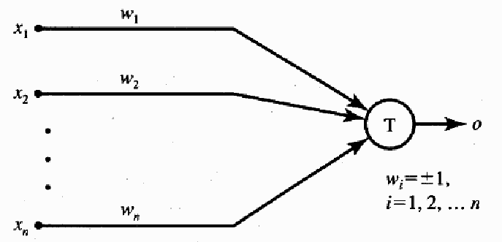

The inputs xi, for i = 1, 2, . . . , n, are 0 or 1, depending on the absence or presence of the input impulse at instant k. The neuron's output signal is denoted as o. The firing rule for this model is defined as follows:



where superscript k = 0, 1, 2, . . . denotes the discrete-time 'instant, and wi is the

multiplicative weight connecting the i'th input with the neuron's membrane. We will assume that a unity delay elapses between the instants k and k + 1. Note that wi = + 1 for excitatory synapses, wi = - 1 for inhibitory synapses for this model, and T is the neuron's threshold value, which needs to be exceeded by the weighted sum of signals for the neuron to fire.

Although this neuron model is very simplistic, it has substantial computing potential. It can perform the basic logic operations NOT, OR, and AND, provided

its weights and thresholds are appropriately selected.

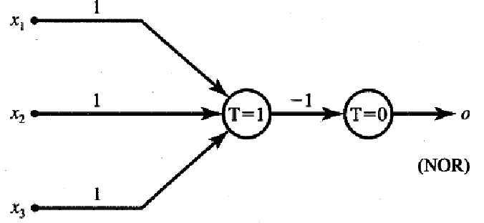

**Experiment:**

Design Mc. Culloc Pitts Model for the following logic functions.

1. AND
2. OR
3. AND NOT
4. NAND
5. NOR

**Conclusion:** The implementation of Mc Culloch Pitts Model was done.